|  |
| --- |
|  |

|  |
| --- |
|  |



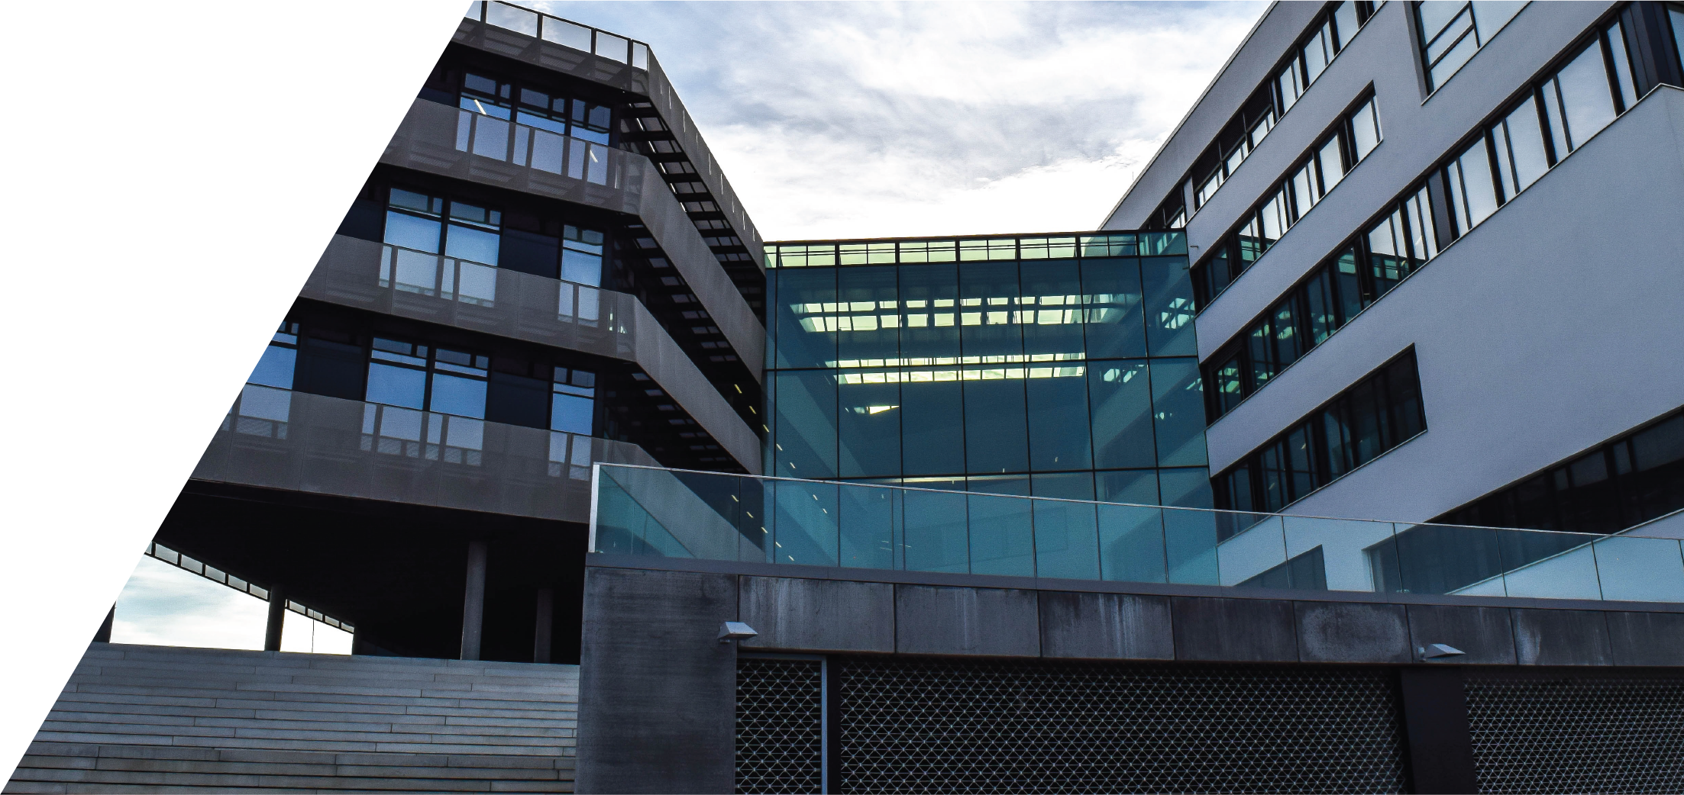

Date: 24-March-2020

Location: Fontys, Eindhoven

Client: Basjan Schouwenaars

Louis Kareem Cocks (Project Leader & Developer) S.N: 3954358

Jose Navarrete Carbonell (Developer) S.N: 3917533

Alexander Vartic (Developer) S.N: 4030435

Menderes Saçli (Developer) S.N: 3838439

Test Case Document

By Atomic Peanuts ©

Table of Contents

Test Cases 2

Recommendations 3



# Test Cases

The current state of the application is working as expected. However, there is a few issues with the data that’s being displayed in the employee system.

Once that issue is fixed, the application will be deployable.

# Recommendations